CLI to Disable Reset to Factory Default_Test Case

Revision History
Version | Date | Author | Description
0.1 | 11/12/2007 | Haihui Zhao | Initial draft

Introduction
When we press reset button of HiveAP more than 5 seconds , the HiveAP will reboot and load bootstrap config(if no bootstrap config will load factory default config).
Now we can use CLI to disable this function. after we disable this function, then we press reset button more than 5 seconds, the HiveAP will reboot but doesn’t load bootstrap config or default config.
This CLI is not useful to reset config, reset config bootstrap or use one-off user name and password to reset config.

In HM :
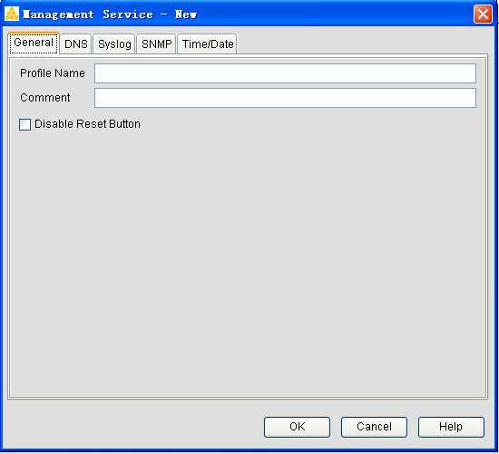

2. Test Topologies



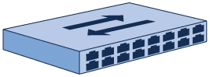

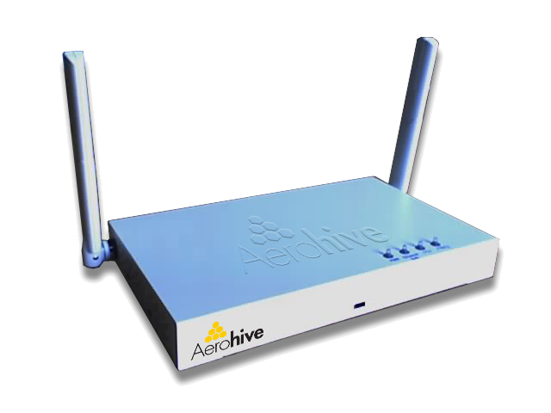

3. Test Points and Strategies

- Check if hardware reset config enabled in reset button default state
(1) Check if load bootstrap config(exist bootstrap config)
(2) Check if load default factory config(no bootstrap config exist)
- Check all reset config operation in disable reset button state
(1) check if hardware reset config disabled (HiveAP does not load bootstrap config or default config)
(2) Check if can reset config by CLI
(3) Check if can reset config bootstrap by CLI
(4) Check if can use one-off user name and password to reset config to default factory
- HM GUI check
- Configure corresponding option and download configuration to HiveAP and check scripts if correctly in HM

4. Software Tools Requirements
- No

5. Hardware Requirements
- Aerohive AP
- Layer 2 Switchs
- Servers

6. Test Schedule

7. Test Case

Case ID Disable_Reset_to_Factory_Default_1
Case ID | Disable_Reset_to_Factory_Default_1
Priority | High
Description | Check if hardware reset config enabled in reset button default state, if load bootstrap config after hardware reset config
Pre-condition | HiveAP in default factory setting
Test procedure | - Login HiveAP  - Create some configurations and save config  - Save config from tftp server to bootstrap  - Press reset button more than 5 seconds  - Check if HiveAP reboot  - After reboot login HiveAP and check if load bootstrap config by CLI
Expectant result | Load bootstrap config, running config is same with bootstrap config
Test result

Case ID Disable_Reset_to_Factory_Default_2
Case ID | Disable_Reset_to_Factory_Default_2
Priority | High
Description | Check if hardware reset config enabled in default state, if load default factory config after hardware reset config
Pre-condition | HiveAP in default factory setting
Test procedure | - Login HiveAP  - Create some configurations and save config  - Press reset button more than 5 seconds  - Check if the HiveAP reboot  - Check if enter CLI wizard
Expectant result | Load default factory config and enter CLI wizard after reboot
Test result

Case ID Disable_Reset_to_Factory_Default_3
Case ID | Disable_Reset_to_Factory_Default_3
Priority | Accept
Description | Verify if hardware reset config successful in disable reset button state
Pre-condition | HiveAP in default factory setting
Test procedure | - Login HiveAP  - Create some configurations  - Disable reset config by reset button by CLI  - Show running config to check if this command exist  - Save config  - Press reset button more than 5 seconds  - Check if the HiveAP reboot  - After reboot login HiveAP and check if load default factory config
Expectant result | The HiveAP reboot but didn’t load default factory config
Test result

Case ID Disable_Reset_to_Factory_Default_4
Case ID | Disable_Reset_to_Factory_Default_4
Priority | Middle
Description | Verify if can reset config by CLI in disable reset button state
Pre-condition | HiveAP in default factory setting
Test procedure | - Login HiveAP  - Create some configurations  - Disable reset button by CLI  - Save config  - Reset config by CLI  - Check if the HiveAP enter CLI wizard
Expectant result | Disable reset button didn’t affect software reset config, the HiveAP enter CLI wizard
Test result

Case ID Disable_Reset_to_Factory_Default_5
Case ID | Disable_Reset_to_Factory_Default_5
Priority | Low
Description | Verify if can reset config bootstrap by CLI in disable reset button state
Pre-condition | HiveAP in default factory setting
Test procedure | - Login HiveAP  - Create some configurations  - Disable reset button by CLI  - Save config  - Save config from tftp server to the HiveAP  - Check if bootstrap config exist by CLI  - Reset config bootstrap by CLI  - Check if bootstrap config exist by CLI
Expectant result | Bootstrap config not exist after reset config bootstrap , disable reset button didn’t affect reset config bootstrap
Test result

Case ID Disable_Reset_to_Factory_Default_6
Case ID | Disable_Reset_to_Factory_Default_6
Priority | Low
Description | Verify if can use one-off user name and password to reset config in disable reset button state
Pre-condition | Use ah_tb to generate a one-off user name and password by the HiveAP’s serial number
Test procedure | - Login HiveAP  - Create some configurations  - Save config from tftp server to bootstrap  - Disable reset button by CLI  - Change superuser name and password  - Save config  - Exit CLI and login using generated one-off user name and password  - Check if the HiveAP reset config to default factory (HiveAP enter CLI wizard, using default superuser name and password can login after reboot)
Expectant result | HiveAP reset config to default factory, that is not affected by disable reset button
Test result

